**PRACTICAL-10**

**AIM:**

Demonstrate wired communication between peer computer using Omnet++

**THEORY:**

**Omnet++:**

* Omnet++ stands for “Objective Modular Network Testbed in C++”
* It is a modular, component-based C++ simulation library and framework, primarily for building network simulators.
* **OMNeT++** is a simulation platform for discrete-event systems.
* Even though it is primarily targeted at simulating computer networks and distributed systems, it cannot be used without any extensions for wireless communication

**Wired Connections:**

* A wired network connection is described as a configuration that involves cables which establish a connection to the Internet and other devices on the network.
* Data is transferred from one device to another or over the Internet using Ethernet cables.

**PRACTICAL IMPLEMENTATION:**

* Firstly, create a new project in omnet++.
* Create .ned file in source folder.
* Then insert two nodes in the canvas.
* After performing the above steps, the topology will be like the below image.

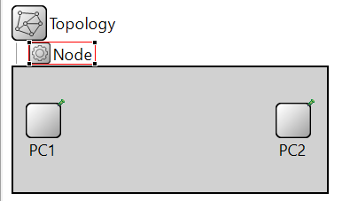

* To connect the nodes, we will define gates.

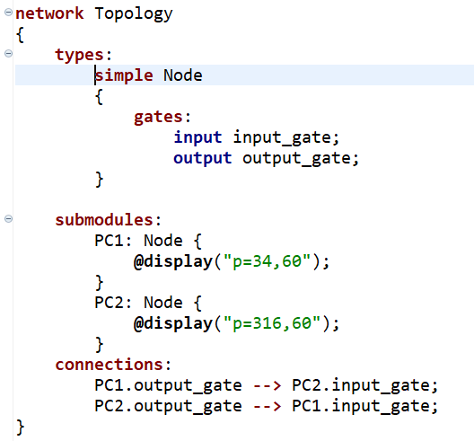

* Topology will look like below image.

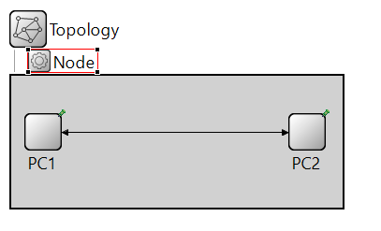

* Now, we will create source file.
* Then, we will write the following code in the source file.

/*

* wiredConnection.cc

*

* Created on: 19-Oct-2021

* Author: Parth Patel 19DCS098

*/

**#include**<omnetpp.h>

**using** **namespace** omnetpp;

**class** Node : **public** cSimpleModule

{

**protected**:

**void** **initialize**() **override**;

**void** **handleMessage** (cMessage *msg) **override**;

};

Define_Module(Node);

**void** **Node :: initialize**()

{

**if**(**strcmp**("PC2",getName())==0)

{

cMessage *msg = **new** cMessage("19DCS098");

send(msg,"output_gate");

}

}

**void** **Node :: handleMessage**(cMessage *msg)

{

send(msg,"output_gate");

}

* Run the project file and following GUI window will open

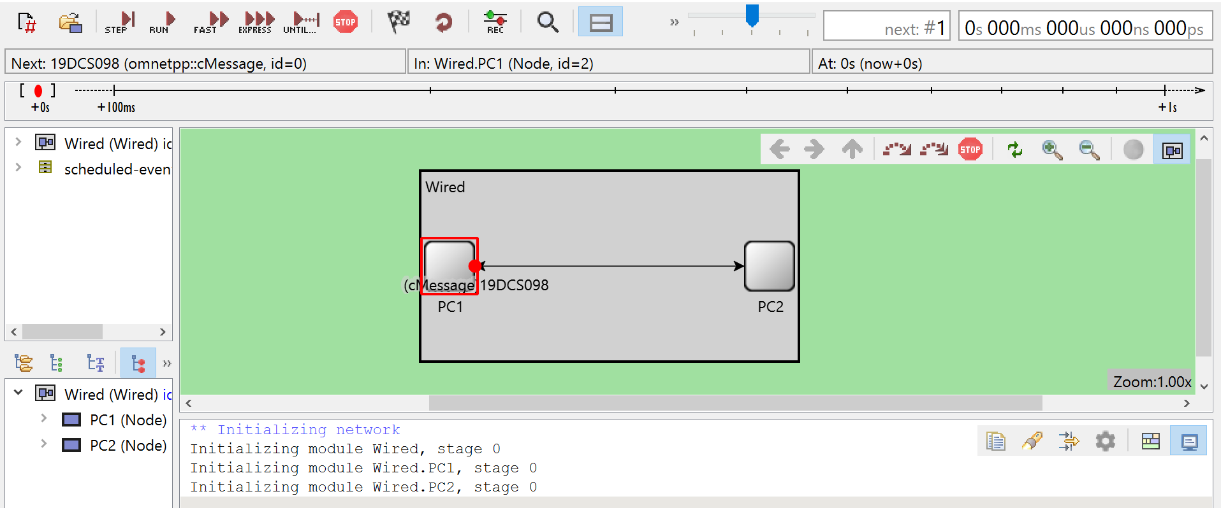

**OUTPUT:**

* Click on run button.

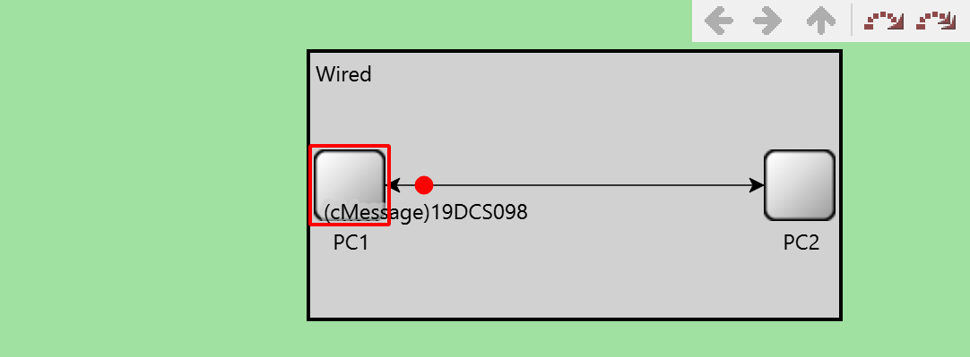

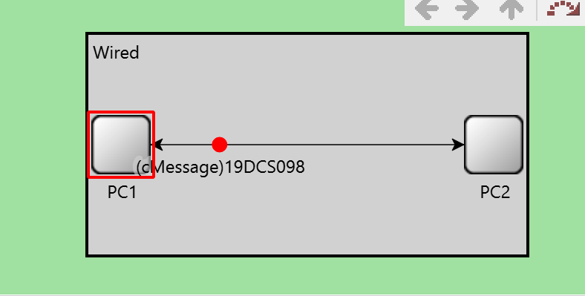

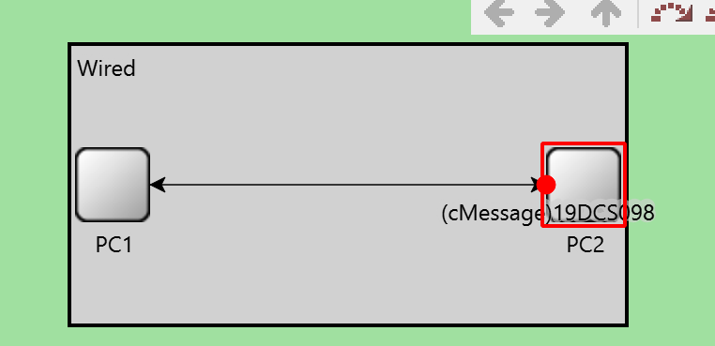

**CONCLUSION:**

* In this practical, we learnt how to configure wired connection in omnet++.
* We also learnt how to test the configuration.